Jukebox Heroes: A Twist on the Rhythm Genre
Design Document
Justin Chang
James Saeger
Twuggle Productions
121-03

Table of Contents

I. Executive Summary……………….…………….…………….…………….…………….………………..…….…..2

II. Game Overview…………….…………….…………….…………….…………….…………….………..…….…….2
- High Concept…………….…………….…………….…………….…………….…………….…….....…….……..2
- Genre…….…………….…………….…………….…………….…………….…………….……………..….………3
- Hooks…….…………….…………….…………….…………….…………….…………….…………….….………3
- License…….…………….…………….…………….…………….…………….…………….……………..….……3
- Gameplay Highlights…….…………….…………….…………….…………………….……………….……….4
- Online Highlights…….…………….…………….…………….…………………….…………….………………5
- Art and Audio Highlights…….…………….…………….…………….…………………….………………….5

III. Production Details…………….…………….…………….…………….…………….…………….……………..6
- Budget…….…………….…………….…………….…………………….…………….……….…….………..…….6
- Schedule…….…………….…………….…………….…………………….…………….…….……….……..…….6

IV. Competition…………….……………..…………….…………….…………….…………….……….……...….…...6

V. Game World…………….…………….…………….…………….………….….…………….…….………………….7
- Backstory…………….…………….…………….…………….…………….…………….….……………………..7
- Objective…….…………….…………….…………….…………………….…………….…………………………7
- Characters…….…………….…………….…………….…………………….…………….………….………..….8
- Mission or Story Progression…….…………….…………….…………….………………….………………8

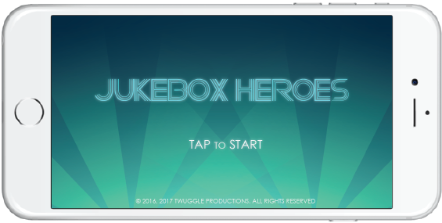

I. Executive Summary

Jukebox Heroes is a hybrid monster collector/rhythm game for mobile platforms. Following the successes of Puzzle and Dragons, Brave Frontier, and Guitar Heroes, Jukebox Heroes features a unique mix of genres, as well as story driven gameplay not found in typical rhythm games.

In Jukebox Heroes, players must lead a team of various musician and composer characters based off famous musical figures from the real world, playing classics as well as original songs through rhythm based tapping gameplay. These characters will have rpg elements such as basic skills, status effects, and most importantly, unique stats that further help differentiate each character from one another. As players progress through the game’s story mode, they will unlock new songs, characters, and accessories for their main avatar. Each unlocked song will also be available in arcade format.

As a mobile game, Jukebox Heroes features a competitive multiplayer mode in which up to 4 players battle head to head for the highest points. Weekly and monthly rewards based on rankings will be a draw for the hardcore and competitive players.

II. Game Overview

High Concept

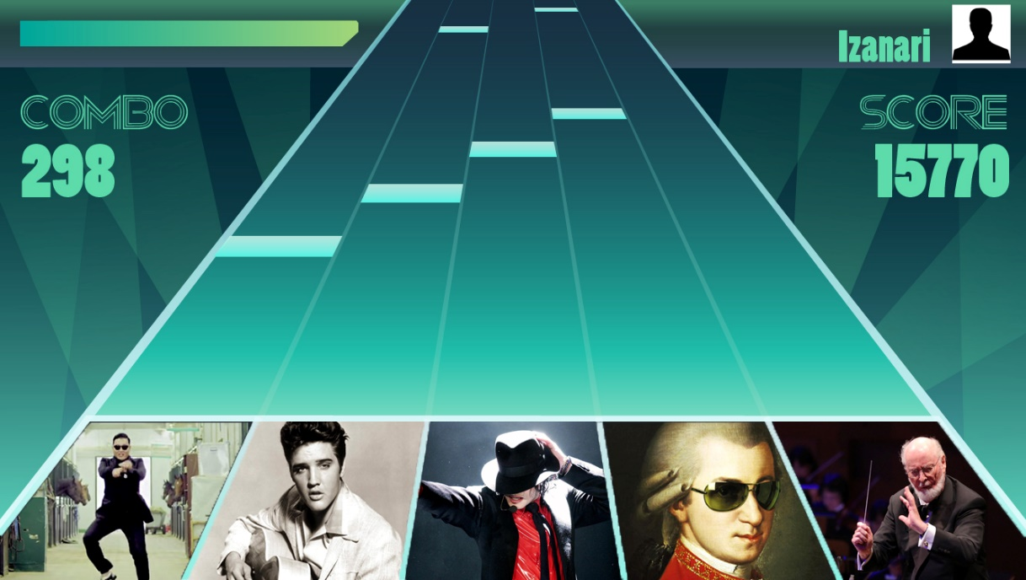

The greatest musicians from across time and space have been summoned into a magical jukebox in order to compete for glory. Band together with other musicians to create the ultimate team, play classic songs from all genres as well as original soundtracks, and hone your tapping skills.

Unlock songs, characters, and accessories in story mode, play through all your favorite songs at will in arcade mode, or show off your skills and your team against other players in exciting one-on-ones or hectic four player free-for-alls in competitive mode!

Genre

Jukebox Hero is an arcade style monster collector/rhythm game with unique collectible characters and competitive modes.

Hooks

Addicting rhythm based gameplay - the falling notes archetype is a genre staple, and will be accentuated by gameplay decisions unique to Jukebox Heroes in that players will be able to augment their playing experience via their personal team of musicians.

Unique collectible characters based off real life musical figures - collectible characters or “cards” as they are often called in the market, is one of the most popular features in the gaming industry. Each character will feature unique art, stats, skills, and effects that adds elements of depth to the gameplay.

Real time competitive mode - allowing players to battle in exciting real time one-on-ones as well as four player free-for-alls is one of the greatest selling points of Jukebox Heroes. Currently in the market there are no real time competitive modes for rhythm games on mobile platforms. Jukebox Heroes’ competitive modes encourage high stakes with weekly and monthly rewards based on rankings.

License

Jukebox Heroes uses many licensed properties - mainly in the form of select licensed songs. While costly, the featured songs would be one of the key selling points of the game. Names of licensed musicians would also be another key component, as the in game collectible characters would be based off of them.

Gameplay Highlights

Very large variety of Collectible Characters, each with individual character portraits. Jukebox Heroes will be released with over 250 characters, with more to come in future updates.
Examples include: Mozart, Beethoven, The Beatles members, Michael Jackson, Beyonce, Louis Armstrong, Elvis Presley, Madonna.

Range of casual to more hard core levels of gameplay for every song. All playable songs will have 3 levels of difficulty: Easy, Normal, and Hard, with the Hard levels pushing the boundaries of human ability.

Story mode in a rhythm game is a very rare occurrence in the industry. Most rhythm games are arcade style, with players maneuvering through a slew of menus to select a song and playing it. Jukebox Heroes ties many songs together in an immersive campaign, with bonus unlockable songs along the way. While a traditional arcade mode exists as well, Jukebox Heroes’ story mode will be a clear focus for newer players who have yet to unlock all the songs and story characters. The story mode is a linear overworld the player must traverse, completing songs and “defeating” musician characters. Once all the main story songs are completed, players can then travel to the next map to complete more songs. The story mode is structured with future updates in mind. More zones/songs will be added as the game matures and continues development.

Tried and true falling note gameplay is a staple in the rhythm game genre, and will be the core gameplay mechanic in Jukebox Heroes. Notes fall on character portraits situated in that row, influencing gameplay in subtle ways.

Gameplay is more than just playing through songs. The key feature that makes Jukebox Heroes so unique is the focus on collecting characters and building teams to tackle challenging songs. While player skill is still the most important factor between two players, their teams have an impact on their performance and overall score in these ways:
Missing notes cause players to lose health - Players naturally start with 500 total HP. Depending on the song and its difficulty, may lose a significant amount of health when missing notes. Easy songs deal an average of 100 damage per missed note, while the hardest difficulty songs deal upwards of 5000 damage.

Characters have stats - A player’s team has up to 5 characters. The player’s HP is the cumulative total of all the characters’ health pools, as well as the 500 base. All characters also have a recovery stat, which is the amount the player heals when successfully hitting a note in that character’s row. Some characters enjoy bonus stats when paired with others. Much like set bonuses for items in other games, using characters from the same band will grant the player a myriad of effects.

Characters have abilities - Each collectible character has their own unique passive abilities. These effects are applied automatically and allow for various playstyles and strategies. On top of passive abilities are active abilities, which have cooldowns and are activated automatically when the cooldowns are up. These active abilities are extremely powerful and designed to induce high moments during gameplay.

Characters grow and become more powerful as players use characters, the characters will gain experience and level up, becoming more powerful with boosted stats. Characters cap out at lvl 99, gaining over double their original base stats over the course of their journey.

Online Highlights

Online multiplayer will be a key element of the game for competitive players. While not necessary for game progression, Jukebox Heroes’ competitive mode will help shift the industry’s focus back to the kind of intense and high stakes gameplay only offered by pitting players against each other. Currently there are no real time competitive modes in mobile rhythm games, and very few in the current generation of rhythm games on PC and console.

In multiplayer mode, players play songs as they would in regular single player. However, they would also be able to see the scores of their competitors at the top of their screen, listed in a ranking system that updates as all players in a match play their songs.

At the end of each week, players are given rewards in the form of in-game currency, based on their ranks. At the end of each season, players are given limited edition rewards such as special skins for their characters.

Art and Audio Highlights

No matter the innovations, as a rhythm game, Jukebox Heroes’ success will largely be dictated by its songlist. As such, it is the utmost priority to acquire popular songs of all genres.

Jukebox Heroes features several well known songs of all genres, such as Pachelbel’s Canon in D major, Beyonce’s Single Ladies, The Beatles’ Hey Jude, and Monstercat’s Restart. Jukebox Heroes also features music from other games in collab events, such as Undertale’s Hopes and Dreams, Final Fantasy X’s To Zanarkand.

III. Production Details

Budget

Every number is approximated due to the fact that Jukebox Heroes has not started production yet.
Planning - $10 thousand
Features - $30 thousand
Infrastructure - $60 thousand
Administration - $20 thousand
Testing - $25 thousand
Developers - $60 thousand per month
Design - $20 thousand
Other - $100 thousand
Song licensing - $300 thousand
People licensing - $250 thousand
Based on sheer approximation, would cost somewhere in the neighborhood of $1 million dollars

Schedule

1 week mark - Developers are found, designers are found, and a rough paper copy of the game is created to give the team a better understanding of what the game will be like.
7 week mark - All songs and character licensing is finished.
12 week mark - All songs and characters are in the game.
15 week mark - Game is ready to be tested by a focus group.
17 week mark - All bugs are fixed and advertising begins.
18 week mark - Game is completely finished and ready to ship out to the world.

IV. Competition

Because Jukebox Heroes is a rhythm/monster collector game, it has to go head to head against both rhythm games and monster collector games. Its top monster collector competitors are Puzzles and Dragons, by GungHo Online Entertainment, and Pokemon Go, made by Niantic. Puzzles and Dragons has been around for 4 years now and is still one of the top monster collector games played, while Pokemon Go was released earlier this year and had the most downloads of any game ever to hit the app store. Puzzles and Dragons key features include a character list with over 3 thousand playable characters, while Pokemon Go has the ever popular Pokemon IP, and its revolutionary AR technology. Deemo—by Rayark Games—a rhythm game released in 2013, is one of the most downloaded rhythm games, and uses songs that mainly feature piano. While Zyon, by Aquatrax Co. is a newer futuristic based rhythm game that focuses more on destroying enemies to unlock new songs. Due to how often each one of these games are updated, they will most likely still be relevant when Jukebox Heroes is released. Jukebox Heroes however has potential to be wildly more successful than any of these games due to its combination of both genres and its mass appeal to fans of real world musicians.

Jukebox heroes is expected to do well in foreign countries–particularly in east Asia, where the rhythm game genre and the monster collecting genre is highly prevalent.

V. Game World

Backstory

The day was January 27th 1756. The greatest musical prodigy, Wolfgang Amadeus Mozart, was born. He started playing the piano at the ripe age of 6 and was composing later that same year. He was considered a genius. Until one day, when Mozart was still young, no more than 25, he was abducted from his home and transported to a strange new world. He ran into Johann Sebastian Bach, a man who he had only heard of in stories. Mozart thought he must be dreaming until he pinched himself and realized he was not. He looked around and saw countless people in ridiculous costumes. He walked over to one and introduced himself, the man replied and said his name was Psy and that it appeared they had been transported into a giant jukebox. That was the day Mozart's life changed forever…
Jukebox Heroes has a wide variety of characters ranging from musicians and composers from the 1600s to musicians and composers from today. The Gods of music were disappointed in the direction music was heading so they brought a large group of musicians together and put them in a jukebox to battle it out.

Objective
Compose your team of five artists must make your way through the jukebox, picking up new characters, until you appease the Gods.

Sample Characters

Wolfgang Amadeus Mozart the Prodigal Musician
HP at lvl 99: 5250
Recovery at lvl 99: 750
Passive Ability: Ultimate Prodigy - Negate miss + 5, Doubles score gain for the first 30% of the song.
Active Ability: Final Requiem - Doubles score gain for the next 12 seconds.

Elvis Presley the King of Rock and Roll
HP at lvl 99: 4975
Recovery at lvl 99: 400
Passive Ability: Icon of the 20th Century - Every 20th combo will add +1000 to score.
Active Ability: Explosive Breakout - Score +5000 for every 18 combo in the next 10 seconds.

Psy the Gangnam Style
HP at lvl 99: 3175
Recovery at lvl 99: 325
Passive Ability: Billion Views - Negate miss +2, Every 5th combo will add +1 to combo
Active Ability: Korean Wave - Double combo generation for the next 10 seconds.

John Williams the Scoremaster
HP at lvl 99: 6500
Recovery at lvl 99: 85
Passive Ability: Hollywood Legend - Allied characters have 20% more HP
Active Ability: Memorable Theme Song - Reduce allies cooldowns by 75%

Mission or Story Progression
In Jukebox Heroes, the player has a starting lineup of five musicians and composers. The player then play songs in order to discover new characters and increase both their hit points and their firepower. In the beginning the game will be fairly simplistic as it teaches players how to play the game without them dying every minute. As the player plays the game more, they will unlock new characters with more HP and better abilities. Once the player has a better understanding of the game and a better team, they can start picking higher difficulties to play each song on. As the difficulty increases, the damage the character takes per missed note increases, the beats per minute increases, and the overall potential scores increase. As the game progresses, the players learn why they have been brought to this giant jukebox and will even have the opportunity to take down the menaces causing all the distress.

